AMRITA VISHWA VIDYAPEETHAM
CHENNAI

Computer Science and Engineering (CSE)

DESIGN AND ANALYSIS OF ALGORITHMS

Roll No: CH.SC.U4CSE24112
Name: Deepak SN
Class: CSE-B
Year: 2024-2028
Design and Analysis of Algorithms
- Quick select:
Code:
#include <stdio.h>
int partition(int arr[], int low, int high) {
int pivot=arr[high];
int i=low;
for(int j=low;j<high;j++){
if(arr[j]<pivot){
int temp=arr[i];
arr[i]=arr[j];
arr[j]=temp;
i++;
}
}
int temp=arr[i];
arr[i]=arr[high];
arr[high]=temp;
return i;
}
int quickSelect(int arr[], int low, int high, int k) {
if(low<=high){
int pivotIndex=partition(arr, low, high);
if(pivotIndex==k)
return arr[pivotIndex];
else if(pivotIndex>k)
return quickSelect(arr, low, pivotIndex-1, k);
else
return quickSelect(arr, pivotIndex+1, high, k);
}
return -1;
}
int main(){
int arr[]={157,110,147,122,111,149,151,141,123,112,117,133};
int n=sizeof(arr)/sizeof(arr[0]);
int k;
printf("Enter k: ");
scanf("%d", &k);
int result=quickSelect(arr, 0, n-1, k-1);
printf("k-th smallest element: %d\n", result);
return 0;
}
Output:
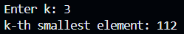
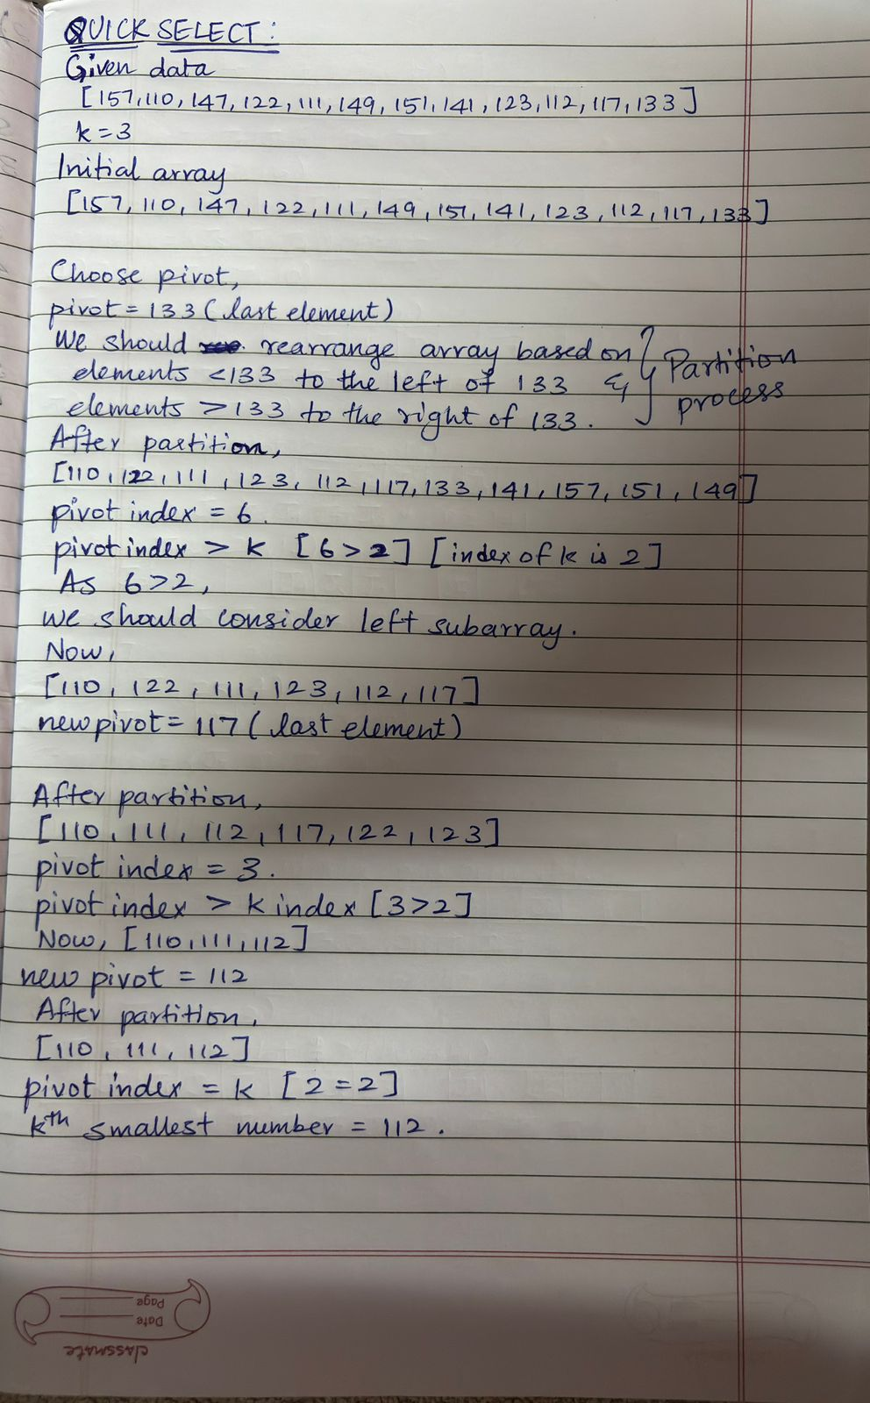
Working:

